Prayers for the Dead: Regaining What We Have Lost

Topic for the Springfield Circuit Winkel of the Missouri District
January 15, 2013
By Pr. Rich Futrell

Our Lutheran Confessions mention in passing that we, as Lutherans, pray for those who have died in the faith. Yet, this understanding that we pray for the dead--and such prayers are not useless, that is, they are of benefit--has largely been lost. Even more, contrary to our Confessions, our current explanation to the Small Catechism teaches us not to pray for the dead. (How did that ever pass doctrinal review?!)

The Lutheran Confessions

“Regarding the adversaries’ quoting the Fathers about the offering for the dead, we know that the ancients speak of prayer for the dead, which we do not ban.” (Ap 24, para 94)

“Epiphanius declares that Aerius [Arius] maintained prayers for the dead are useless. He finds fault with this. We do not favor Aerius either.” (Ap 24, para 96).

The LC-MS Explanation to the Small Catechism (1986 edition)

201. For whom should we pray?

We should pray for ourselves and for all people, even for our enemies, but not for the souls of the dead.

From the New Testament, we examine the faith believed and practiced with two people: Martha of Bethany and the Apostle Paul.

Jesus Goes to Raise Lazarus from the dead

Read John 11:17-27

In these verses, we see a profound confession of faith from Martha.

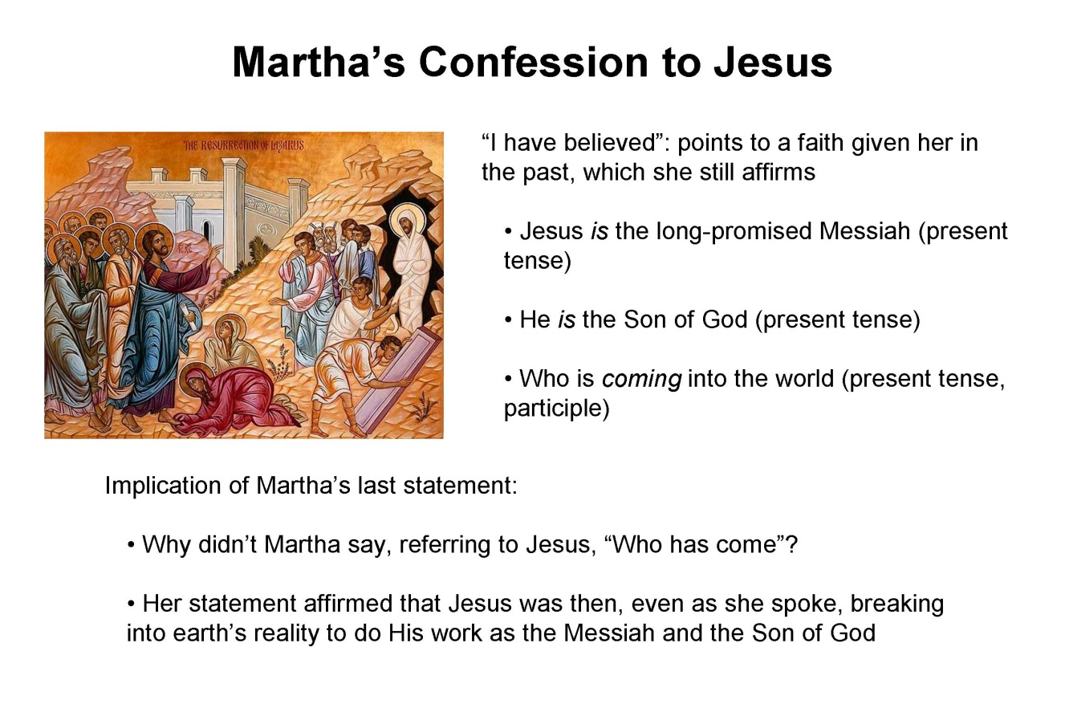
So, we get a glimpse of the deep faith Martha has. Yet, she clearly doesn’t think that Jesus was in Bethany to raise Lazarus from the dead. We see that in their dialogue.

- John 11:24: [Martha said, responding to Jesus saying that Lazarus will rise again,] “I know that he will rise again on the last day.”

- John 11:39: [When Jesus was getting ready to raise Lazarus from the dead:] Jesus said, “Take away the stone.” Martha, the sister of the dead man, said to him, “Lord, by this time there will be an odor, for he has been dead four days.”

- So then, what was Martha asking Jesus to do for Lazarus when she said, “I know that whatever you ask from God, God will give you” (vs. 22)? What do we call what she asked Jesus to do?

Based on the setting and context, Martha had asked Jesus to pray for Lazarus who had been dead for four days.

The Apostle Paul Prays for Onesiphorus

Read 2 Timothy 1:16-17

- In what tense does Paul refer to Onesiphorus, past or present?

Beyond, “Greet one another with a holy kiss,” when Paul asked the recipients of an epistle to greet others, he normally mentioned them by name. Sometimes, he expanded the greeting to include those associated with the person to greet:

  - Romans 16 (many people are listed individually to greet)
  - “Greet Philologus and Julia, Nereus and his sister, and Olympas and all the saints who are with them” Romans 16:15
  - “to Nympha and the church that is in her house” Colossians 4:15

- Some exceptions to the way of Paul normally requested readers of his epistles to greet others:

  - “Greet those in the household of Narcissus” Romans 16: 11
  - “Greet Prisca and Aquila, and the household of Onesiphorus” 2 Timothy 4:19

  - Why didn’t Paul simply say, “Greet Onesiphorus and his household,” which would have been his normal way of asking others to greet them?

  - What does Paul’s past-tense verb usage when referring to Onesiphorus in 2 Timothy 1:16-17 and the lack of “Greet Onesiphorus” in 2 Timothy 4:19 tell us?

Read 2 Timothy 1:18

- What does Paul do for Onesiphorus?

- What is the prayer for?

The understanding that Onesiphorus was dead and that Paul prayed for him has been the New Testament Church’s understanding from the very beginning. The Church’s universal practice into the Reformation of prayers for the dead simply showed that understanding.

A Few Early-Church References on Prayers for the Dead

- “The Bishop . . . does not offer prayers for the unsainted dead.” (St. Dionysius the Areopagite, died 96 AD, believed to have been baptized by the Apostle Paul)

- Tertullian (160-225): “The widow who does not pray for her dead husband has as good as divorced him.”

- The Canons of Hippolytus (336-340) explicitly mention prayers for the dead during the Divine Service.

- Ambrose (340-397) in his funeral sermon for the Emperor Theodosius (395): "Give perfect rest to Your servant Theodosius, the rest which You have prepared for Your saints.”

- Cyril of Jerusalem (315-386): “Then we pray for the holy Fathers and Bishops who have fallen asleep before us, and for all who have died in our communion, believing that the souls for whom prayers are offered receive very great assistance.”

- Augustine in His Confessions quoting his mother, Monica, on her deathbed: “I have only one request to make of you, that you remember me at the altar of the Lord, wherever you may be.” (Book 9, chapter 11)

What our Lutheran Confessions Say

- “Regarding the adversaries’ quoting the Fathers about the offering for the dead, we know that the ancients speak of prayer for the dead, which we do not ban.” (Ap 24, para 94)

- “Epiphanius declares that Aerius [Arius] maintained prayers for the dead are useless. He finds fault with this. We do not favor Aerius either.” (Ap 24, para 96).

So, in passing, our Confessions say that we disagree with Arius and, instead, agree with Epiphanius (320-403 AD) about praying for the dead. Yet, we will not understand what our Confessions teach unless we read what Epiphanius wrote on the topic of praying for the dead. Here is what Epiphanius of Salimus wrote, also in passing, when he was dealing with the false teaching of the Arians:

Prayers are also given on their behalf [those who have died in the faith], even if it does not force back the guilty charges laid against them. It is also useful because we, in this world, often stumble, either inadvertently or deliberately, and so it reminds us of something more perfect. For we remember both the righteous [those in heaven] and sinners [those still here on earth]. For sinners, we pray for God’s mercy. We pray for the righteous: The Fathers, Patriarchs, Prophets, Apostles, Evangelists, martyrs, confessors, bishops, and monks, and of the whole list of them. Yet, we set apart our Lord Jesus Christ from the whole of humanity because of the honor due Him, and give reverence to Him, while keeping in mind that the Lord is not on the same level with any man, even if that man has performed a million righteous deeds or more. (Panarion 75.8)

When our Lutheran Confessions mention, in passing, prayers for the dead, it shows that we had no disagreement about that practice. That it is mentioned as being acceptable and even useful as if it’s no big deal shows exactly that.

Optional: The First “Lutheran” Prayers for the Dead in English

In 1531, the King Henry VIII sent Thomas Cranmer to Germany to arrange an alliance with the Lutheran princes. In 1532, Cranmer married a niece of the German Lutheran theologian Andreas Osiander. Under the influence of Lutherans, Cranmer put together the first English language Book of Common Prayer in 1549. It was basically the first Lutheran prayer book in English.

Yet the Protestant elements within the Anglican Church still considered the “Lutheran” prayerbook too “Romish.” So a revision was made in 1552. Some changes included:

- The words that taught “the body and blood of Christ to be under the form of bread and wine” were altered and removed the terms “body” and “blood.”
- The word “Mass” was changed everywhere in favor of “Holy Communion.”
- Prayers for the dead were removed.

These prayers for the person being buried at a funeral were removed:

Grant, we beseech thee, that at the day of judgment his soul and all the souls of thy elect, departed out of this life, may with us and we with them, fully receive thy promises, and be made perfect altogether through the glorious resurrection of thy son Jesus Christ our Lord.

O Lord, with whom do live the spirits of them that be dead: and in whom the souls of them that be elected, after they be delivered from the burden of the flesh, be in joy and felicity [happiness]: Grant unto us thy servant, that the sins which he committed in this world be not imputed unto him, but that he, escaping the gates of hell and pains of eternal darkness may ever dwell in the region of height, with Abraham, Isaac, and Jacob, in the place there is no weeping, sorrow, nor heaviness: and when that dreadful day of the general resurrection shall come, make him to rise also with the just and righteous, and receive this body again to glory, then made pure and incorruptible, set him on the right hand of thy Son Jesus Christ, among thy holy and elect, that then he may hear with them these most sweet and comfortable words: “Come to me ye blessed of my father, possess the kingdom which hath been prepared for you from the beginning of the world”: Grant this we beseech thee, o merciful Father: through Jesus Christ our mediator and redeemer. Amen.

Prayers for the Dead in the LC-MS

- Refresh the soul that has now departed with heavenly consolation and joy, and fulfill for it all the gracious promises which in Your holy Word You have made to those who believe in You. Grant to the body a soft and quiet rest in the earth till the Last Day, when You will reunite body and soul and lead them into glory, so that the entire person who served You here may be filled with heavenly joy there. (Starck’s Prayer Book, Revised Concordia Edition, pg. 345 [Johann Friedrich Starck (1680-1756), published by CPH in English in 1921 and reprinted in 2009])

- The funeral service in Lutheran Service Book has this prayer: “Give to Your whole Church in heaven and on earth Your light and Your peace. . . . Grant that all who have been nourished by the holy body and blood of Your Son may be raised to immortality and incorruption to be seated with Him at Your heavenly banquet.”

Appropriate Prayers for the Dead

To pray that a dead person’s time in Purgatory will be shortened is a bad example of what a prayer for the dead was meant to be. Within Roman Catholicism, such a prayer for the dead fits their theology and so is part (but not all) of their prayers for the dead. A misuse of a prayer for the dead does not mean that all prayers for the dead are wrong. But it has been fear of things Roman Catholic that has stopped us over the centuries from praying for the dead in Christ.

When Lutherans pray for the dead, it confesses that those for whom we pray are at rest with Christ, for we would not pray for someone we believe who would be damned. The prayer is a strong Amen back to God, saying: “These saints now rest with you; bless them ever, O Lord! They now rest with You; remember them on the Last Day!”

If someone should object to praying for something that one already has, then he should also stop praying the Lord’s Prayer. For then there would be no need to ask for daily bread “this day.” Yet, even though God meets are needs, we are told to pray such a prayer.

II. What We Lost When We Stopped Praying for the Dead as Part of our Common Practice

1. Psychological Closure

Prayers for the dead--especially at a funeral--comfort those still living on earth. It does so because it affirms the communion of saints. It also helps provide psychological “closure” for those grieving. It allows those who are mourning to cry out to God in prayer for the loved one who has died. Not allowing this keeps one from praying to God for the one who has died.

2. Our View of Salvation became Two-Dimensional

Through faith, salvation is a gift that God bestows (Ephesians 2:8). If so, then when did (or does) God give a person this gift of salvation?

Ephesians 1:4: God chose us in Christ, before the foundation of the world, to be holy and blameless in His sight.

- When were you saved? Before the foundation of the world was ever created?

John 19:30: Jesus said, “It is finished!”

- When were you saved? When Jesus died on the cross 2,000 years ago.

1 Peter 3:21: Baptism now saves you, not the removal of dirt from the flesh, but an appeal to God for a good conscience through the resurrection of Jesus Christ.

- When were you saved? When the waters of baptism came to you, forgiving your sin and bring you into God’s family.

Romans 10:17: Faith comes from hearing, and hearing through the word of Christ.

- When were you saved? When the Word of God came to you and created, and continues to create, faith in your heart.

1 Corinthians 1:18: For the word of the cross is folly to those who are perishing, but to us who are being saved it is the power of God.

- When are you saved? Whenever the Word of the cross still comes to you, here and now, in the present tense.

Romans 5:9: Since we have now been declared righteous by Christ’ blood, we will be saved through Him from wrath.

- When will you be saved? When Jesus admits you into His eternal presence.

You are saved. You are being saved. You will be saved. (This also answers the question, “Why should I go to Church?” To be saved!) Yet, the finality of our salvation is not until the Last Day, when body and soul are reunited. In other words, those now in eternity are still awaiting their final salvation! We see this depicted in the book of Revelation.

In Revelation, whenever John sees active, heavenly worship, two words describe what he sees: pipto (fall down) and proskeneuo (in a position of prostration) (Revelation 4:10, 5:14, 7:11, 11:1, 11:16, 15:4, 19:4, 19:10). The only exception to this is Revelation 7:15, where the angel is describing to John those who worship God in heaven.

Those who are sinless and in heaven worship God by falling before Him and lying flat in His presence. How much more should such reverential postures take place in our worship? For Hebrews 8:5 says that our worship on earth is a copy and shadow of what is in heaven.

Yet, after Jesus returns on the Last Day, and the bodies and souls of the saints are reunited, what Revelation describes has changed. The saints are no longer worshiping God in the form of pipto and proskeneuo. Revelation 22:3-5 reads:

³No longer will there be anything accursed, but the throne of God and of the Lamb will be in it, and his servants will worship [latreuo] him. ⁴They will see his face, and his name will be on their foreheads. ⁵And night will be no more. They will need no light of lamp or sun, for the Lord God will be their light, and they will reign forever and ever. [ESV]

Now the saints worship God in the form of latreuo. But more than that, they will also reign with God in eternity!

3. Our View of the Church Became Flattened

When we stopped praying for the dead, our understanding of what it means to be Church changed. In God and His Church, an inseparable division does not exist between the living and the departed in all areas. For example: The saints in heaven pray for us (Revelation 6:9-10). They are the great cloud of witnesses encouraging us to run the race of faith (Hebrews 12:1).

When we don’t pray for those who are in God’s eternal presence, our poor practice of prayer begins to shape what we believe. We naturally begin to think that an insurmountable breech exist between the saints on earth and the saints in heaven.

The Church includes those in the Church Militant and the Church Triumphant. We are in one Church. We are all one in the love of God the Father. Whether we are in time or in eternity, as members of the one, true Church, we still belong to the same family, and are still called to help bear one another’s burdens. One does not stop being a member of the Church simply because he happens to die. Death does not sever the bond of mutual love that links the members of the Church together.

It was not until 1439, at the Council at Florence, when Purgatory officially became a doctrine of the Roman Catholic Church. Later, at the Council of Trent (Session 25), the Roman Catholic Church asserted: “The Catholic Church, instructed by the Holy Ghost, has from Sacred Scriptures and the ancient traditions of the Fathers, taught in Sacred Councils, and very recently in this Ecumenical Synod, that there is a Purgatory, and that the souls therein detained are helped by the suffrages of the faithful, but principally by the acceptable sacrifice of the altar.”

