P | Whoever desires to be saved must, above all, hold to the catholic faith.
C | Whoever does not keep this faith whole and undefiled will, without doubt, perish eternally.
P | And the catholic faith is this:
C | We worship one God in three persons and three persons in one God, without confusing the persons or dividing the divine Being.
P | For the Father is one person, the Son is another, and the Holy Spirit is another.
C | But the deity of the Father and of the Son and of the Holy Spirit is one, equal in glory, coequal in majesty.

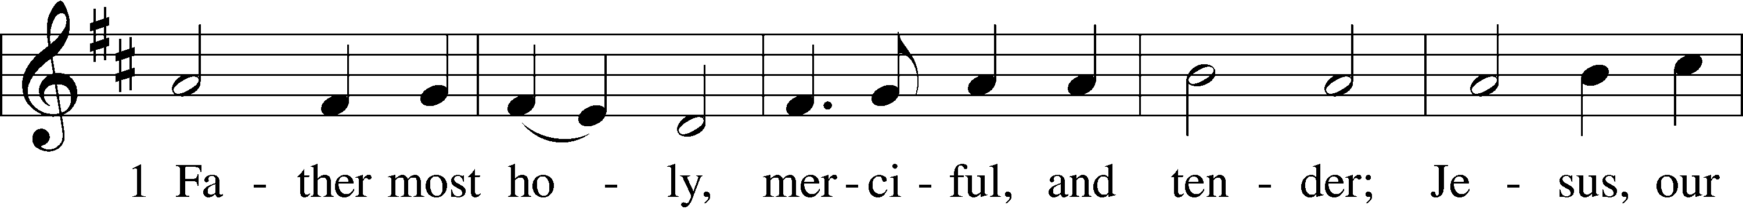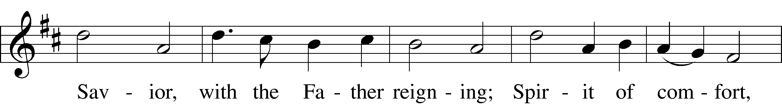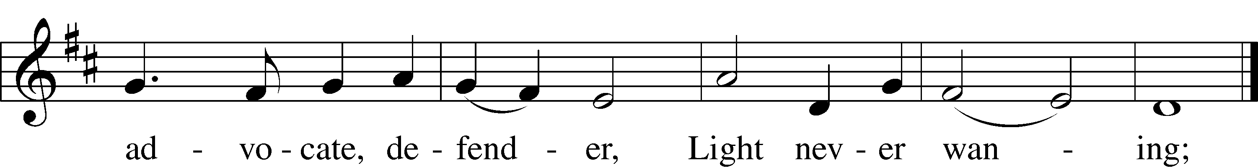
P | Such as the Father is, such is the Son, and such is the Holy Spirit.
C | Uncreated is the Father; uncreated is the Son; uncreated is the Holy Spirit.
P | The Father is infinite; the Son is infinite; the Holy Spirit is infinite.
C | Eternal is the Father; eternal is the Son; eternal is the Holy Spirit.
P | And yet they are not three who are eternal, but one who is eternal,
C | just as they are not three who are uncreated, nor three who are infinite, but one who is uncreated and infinite.

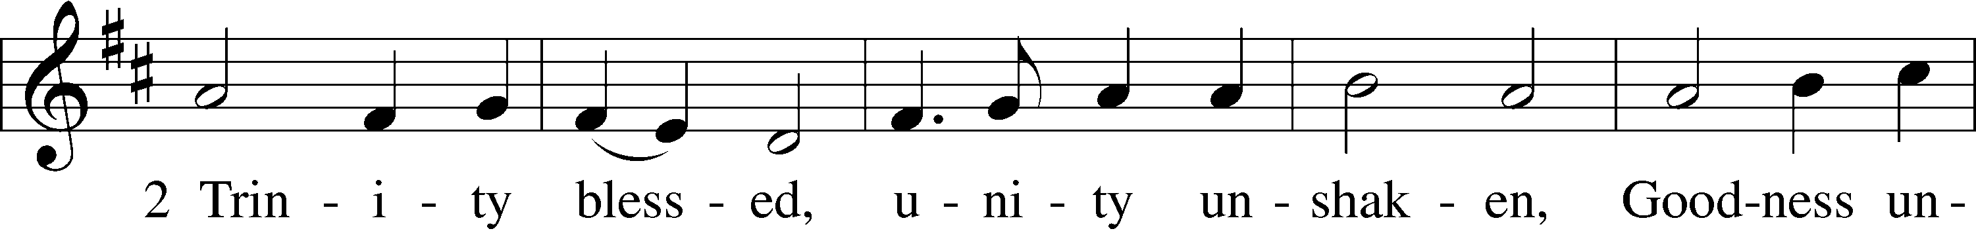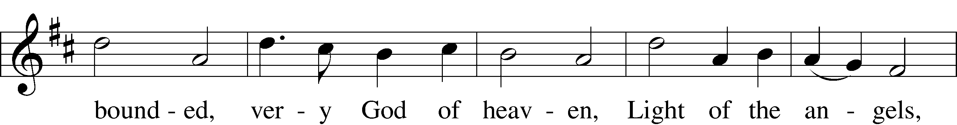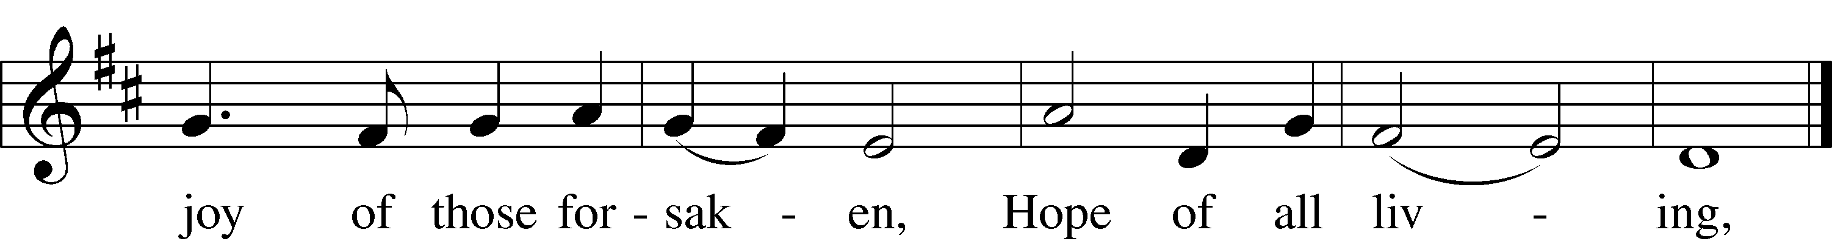
P | Almighty is the Father; almighty is the Son; almighty is the Holy Spirit.
C | And yet they are not three who are almighty, but one who is almighty.
P | So the Father is God, the Son is God, the Holy Spirit is God;
C | and yet they are not three gods, but one God.
P | So the Father is Lord, the Son is Lord, the Holy Spirit is Lord;
C | and yet they are not three lords, but one Lord.
P | For just as Christian truth compels us to confess each distinct person as God and Lord,
C | so the catholic faith forbids us to speak of three gods or three lords.

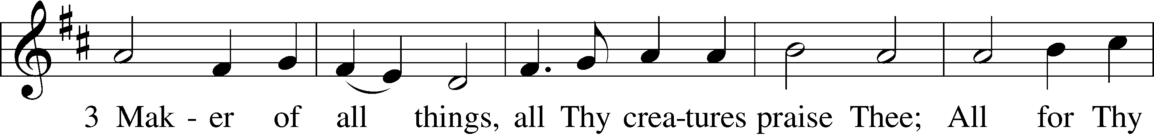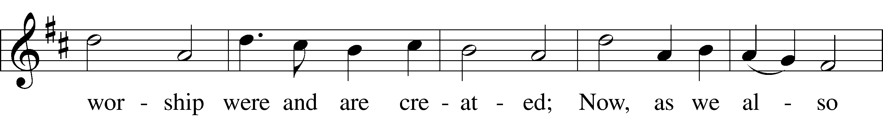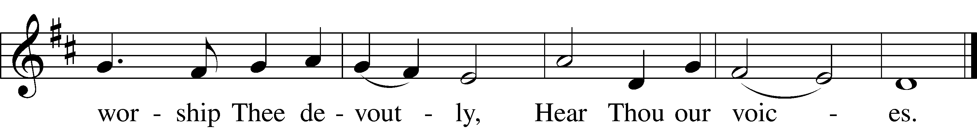
P | The Father was neither made nor created nor begotten;
C | the Son was neither made nor created, but was alone begotten of the Father;
P | the Holy Spirit was neither made nor created, but is proceeding from the Father through the Son.
C | Thus, there is one Father, not three Fathers; one Son, not three Sons; one Holy Spirit, not three Holy Spirits.
P | And in this Trinity none is before or after, greater or less than the other;
C | but all three persons are in themselves coeternal and coequal, so that in every way, as stated before, the Trinity in Unity and Unity in Trinity is to be worshiped.
P | Therefore, whoever wishes to be saved must think thus about the Trinity.

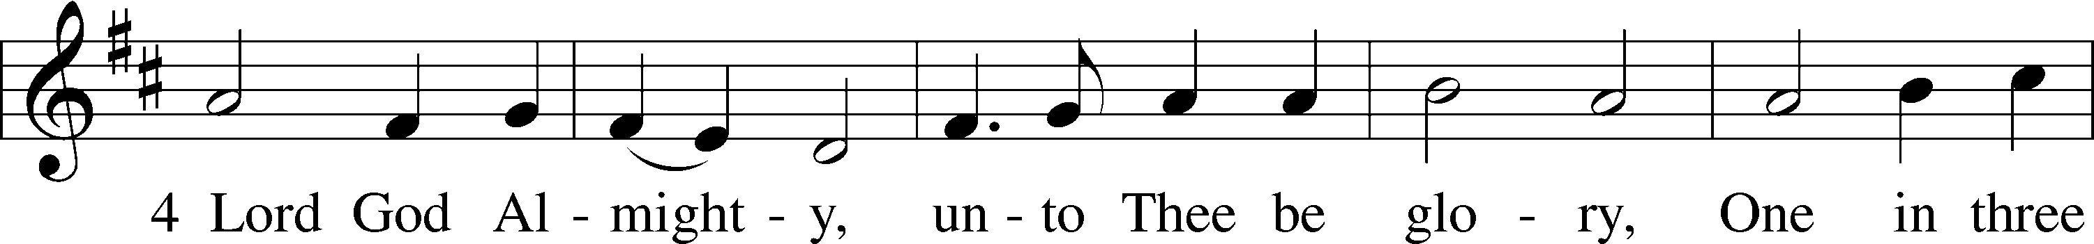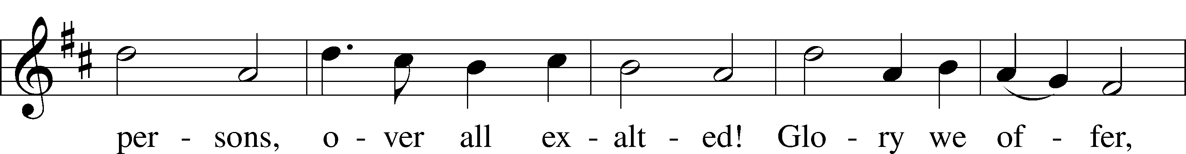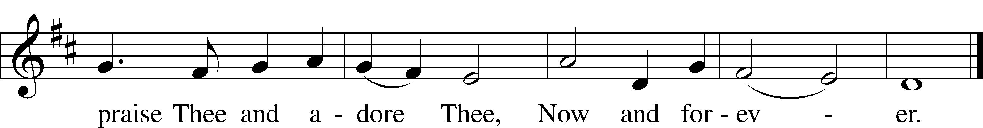
P | But it is also necessary for everlasting salvation that one faithfully believe that our Lord Jesus Christ took on human flesh.
C | For this is the true faith that we believe and confess: That our Lord Jesus Christ, the Son of God, is at the same time both God and man.
P | He is God from the Being of the Father before all ages, and He is man from the being of His mother in this age:
C | Fully God and fully man, composed of a rational soul and human flesh;
P | equal to the Father with respect to His divinity, less than the Father with respect to His humanity.

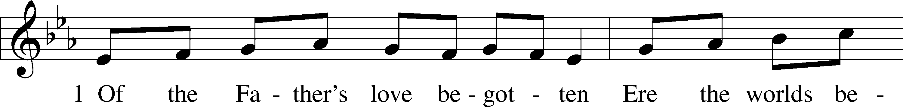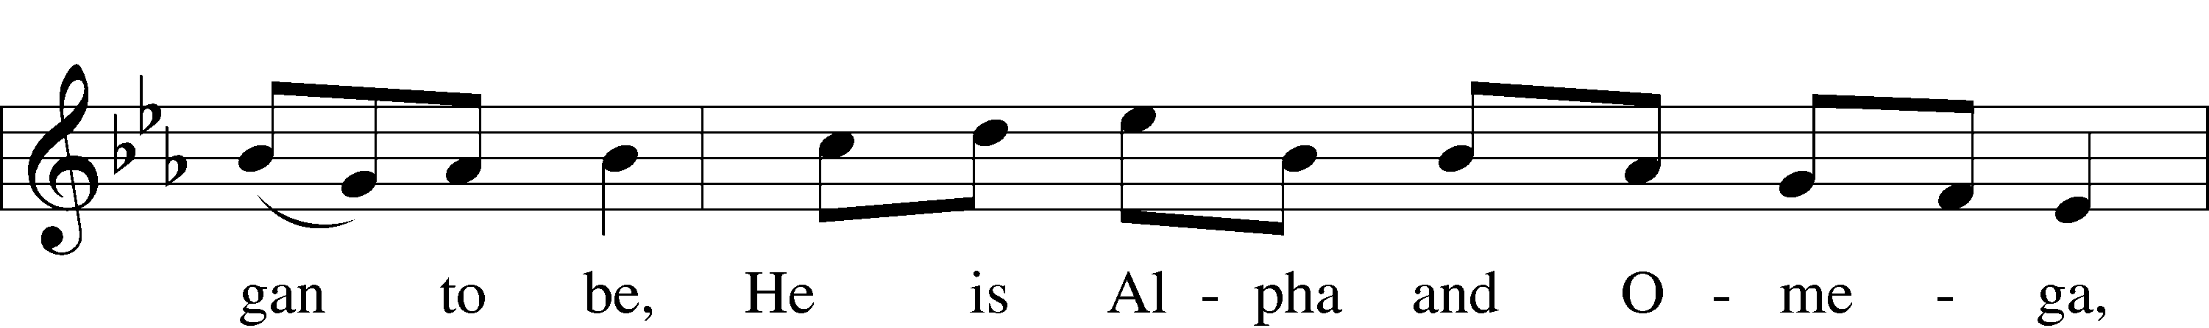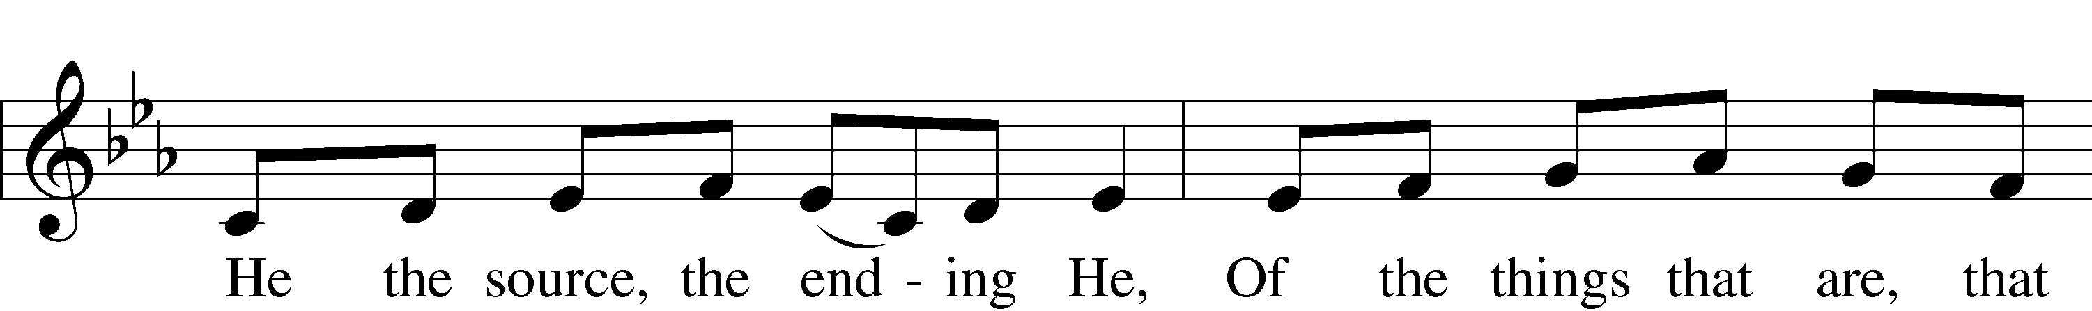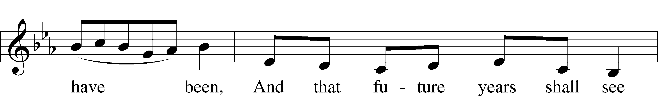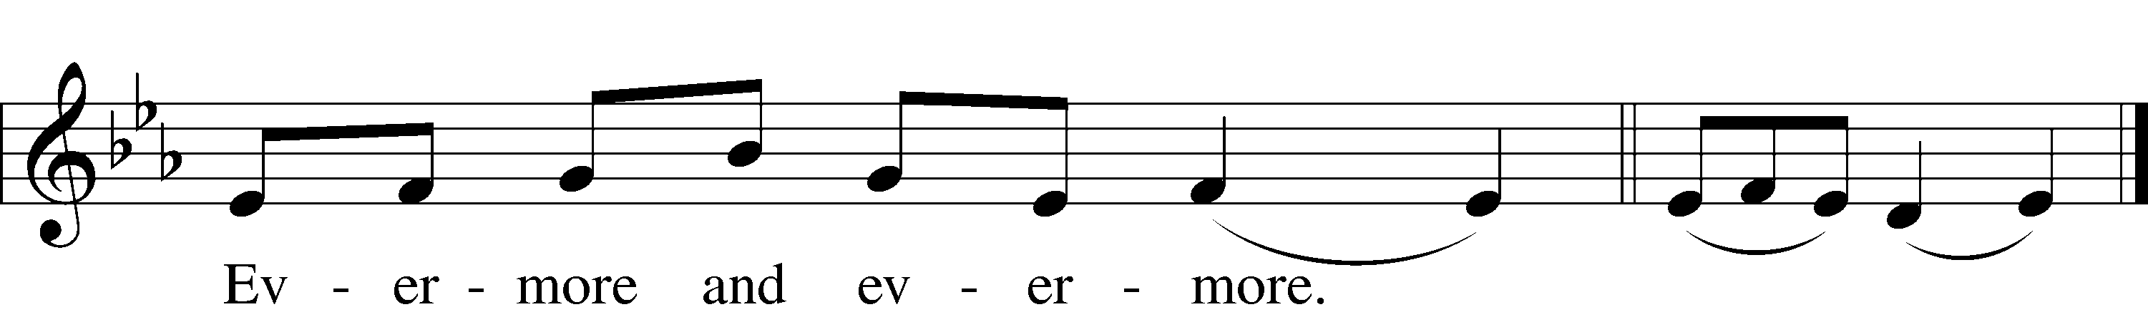
P | Although He is God and man, He is not divided, but is one Christ.
C | He is one, not by changing the divinity into flesh, but by taking the humanity into God;
P | fully one, not by confusion of human and divine being, but by unity of person.

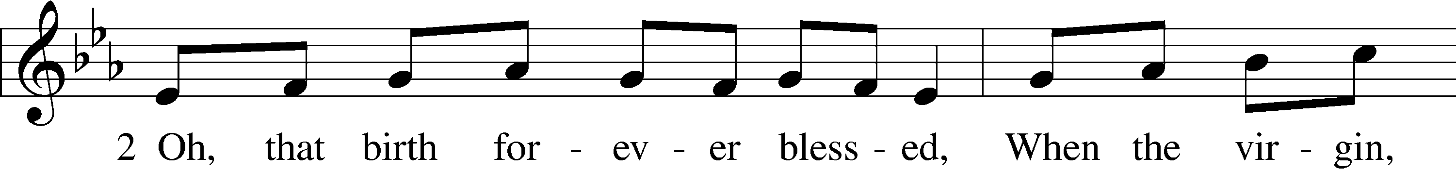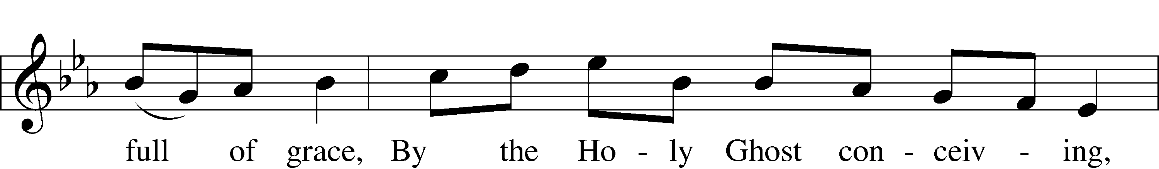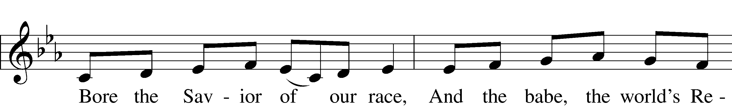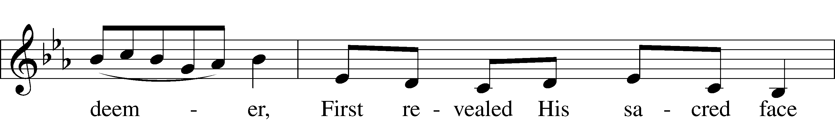
P | For as the rational soul and flesh is one man, so God and man is one Christ.
C | He suffered for our salvation, descended into hell, rose the third day from the dead,
P | ascended into heaven, and is seated at the right hand of the Father, God Almighty, from where He will come to judge the living and the dead.
C | At His coming all people will rise bodily and give answer for their deeds.
P | Those who have done good will enter into eternal life, and those who have done evil into eternal fire.

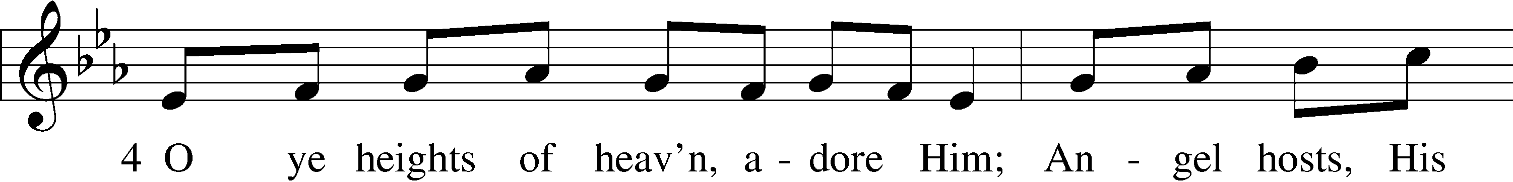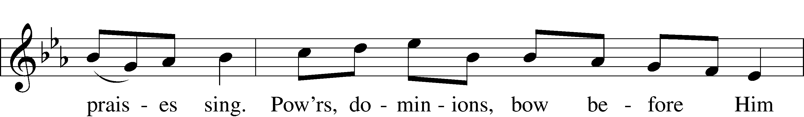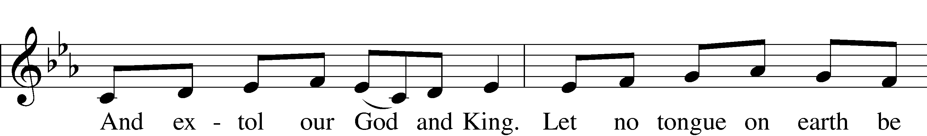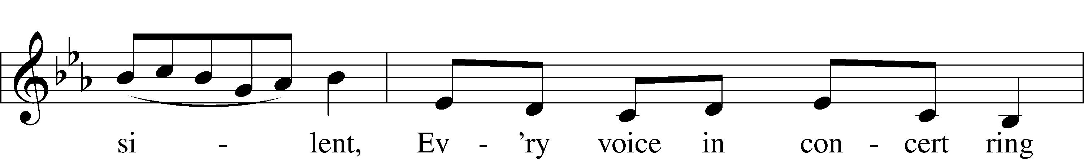
P | This is the catholic faith.
C | Whoever does not faithfully and firmly believe this will not be saved.

