The Funeral Service for Bobbie J. Hansen

November 21, 2014
Gorman-Scharpf Funeral Home, Springfield, Missouri
Pastor Richard Futrell officiating

Eulogy by the Reverend Jim Troyke

Stand

The sign of the cross may be made by all in remembrance of their Baptism.

Invocation and Greeting
P In the name of the Father and of the T Son and of the Holy Spirit.
C Amen.

P On this solemn day, we gather here to seek God’s comfort in our sorrow, but also to rejoice in the promise of the resurrection.

Grace and peace to you from God our Father and our Lord T Jesus Christ, who said, “Come to me, all who are weary and burdened, and I will give you rest” (Matthew 11:28).

Comfort from God’s Word
P Praise to God our Father and Lord Jesus Christ, who comforts us in all our troubles. It is as the Apostle Paul writes, “The wages of sin is death, but the gift of God is eternal life in Christ Jesus our Lord” (Romans 6:23). And Jesus gives us this comfort: “I am the Resurrection and the Life. The one who believes in me will live even if he dies. Everyone who lives and believes in me will never die” (John 11:25-26).

Psalm Psalm 121
P I raise my eyes toward the mountains.
C From where will my help come?

P My help is from the Lord,
C the maker of heaven and earth.

P He will not allow your foot to slip;
C your protector will not slumber.

P Indeed, the protector of Israel
C will neither slumber nor sleep.

P The Lord is your protector;
C the Lord is your shade at your right hand.

P The sun will not strike you by day,
C nor the moon by night.

P The Lord will protect you from all evil;
C he will watch over your life.

P The Lord will guard your going out and your coming in
C from this time forth and even forevermore.

C Glory be to the Father and to the Son and to the Holy Spirit,
as it was in the beginning, is now, and will be forever. Amen.

Kyrie
P Lord, have mercy on us.
C Christ, have mercy on us.
Lord, have mercy on us. (Mark 10:47)

Baptismal and Resurrection Comfort
P In Holy Baptism, Bobbie was clothed with the robe of Christ’s righteousness that covered all her sin. It is as the Apostle Paul says: “Do you not know that all who were baptized into Christ Jesus were baptized into his death?
C Therefore, through baptism we were buried with Him into His death, so that just as Christ was raised from the dead by the Father’s glory, we too can walk in newness of life. For if we have been united with Him in the likeness of His death, we will also be united with Him in the likeness of His resurrection.” (Romans 6:3-5)

P All of you who were baptized into Christ
C have clothed yourselves with Christ. (Galatians 3:27)

P When what is perishable is clothed with the imperishable,
C and what is dying is clothed with what cannot die,

P then the written Word will be fulfilled:
C “Death has been swallowed up by victory!” (1 Corinthians 15:54)

P When Christ, who is our Life, appears,
C then we, too, will appear with Him in glory. (Colossians 3:4)

P He will transform our lowly bodies
C into the likeness of His glorious body. (Philippians 3:21)

P We will need no lamp or sun because the Lord God will shine on us.
C And we will reign with Him forever and ever. (Revelation 22:5)

P And so we will be with the Lord forever.
C So then, comfort one another with these words. (1 Thessalonians 4:17-18)

Salutation and Collect of the Day
P The Lord be with you.
C And with your spirit.

P Let us pray.
O God of all grace and mercy, You sent Your Son Jesus to destroy the power of death and to open the kingdom of heaven to all believers. Assure us that because He lives, we too will live. Comfort us with Your promise that neither death nor life, nor things present nor things to come, can separate us from Your love that is in Christ Jesus our Lord.
C Amen.

Sit

Old Testament Reading Isaiah 26:1-4, 19
On that Day, this song will be sung in the land of Judah:

Ours is a strong city! The Lord’s salvation, like walls and fortifications, makes it secure. Open your gates, so the righteous nation may enter—one that remains faithful. In perfect peace, you will protect those who keep the faith, because they trust in you. Trust in the Lord forever, for in the Lord God you have an everlasting rock…. Your dead will live; their bodies will rise. Those who lie dead in the dust will arise and shout for joy!

P This is the Word of the Lord.
C Thanks be to God.

Epistle 1 Thessalonians 4:13-18
Brothers, we do not want you to be uninformed about those who are asleep [those who have died], so that you will not grieve like others who have no hope. Since we believe that Jesus died and rose, so also we believe that God will bring with him those who have fallen asleep in him. We tell you this by the Word of the Lord: We who are still alive at the Lord’s coming will not precede those who have fallen asleep. For the Lord himself will descend from heaven with a shout of command, with the archangel’s call, and with the sound of God’s trumpet, and the dead in Christ will rise first. Then, together with them, we who are still alive will be taken in the clouds to meet the Lord in the air. And so we will be with the Lord forever. So then, encourage one another with these words.

P This is the Word of the Lord.
C Thanks be to God.

Stand

Verse
P Alleluia, alleluia.
Jesus Christ is the firstborn of the dead; (Colossians 1:18)
C to Him be glory and power forever. Alleluia. (Revelation 19:1)

Holy Gospel John 6:27-40
P The Holy Gospel according to St. John, the 6th chapter.
C Glory to You, O Lord.

[Jesus said:] “Don’t work for the food that perishes but for the food that endures to eternal life, which the Son of Man will give you, because God the Father has put his seal of approval on him.”

So they asked him, “What then does God want us to do?”

Jesus replied, “This is God’s work—that you believe in the one he has sent.”

They then asked, “What miraculous sign are you going to do so that we may see it and believe you? What will you do? Our ancestors ate the manna in the wilderness, just as it is written: ‘He gave them bread from heaven to eat.’”

Jesus told them, “I assure you: It wasn’t Moses who gave you the bread from heaven; it is my Father who gives you the true bread from heaven. The bread of God is the one who comes down from heaven and gives life to the world.”

Then they said, “Sir, give us this bread all the time.”

Jesus told them, “I am the bread of life. Whoever comes to me will never be hungry, and whoever believes in me will never be thirsty. I told you that you have seen me and still you do not believe. Everything the Father gives me will come to me, and the one who comes to me I will never turn away. I have come down from heaven, not to do my own will, but the will of the one who sent me. And this is the will of the one who sent me: That I should lose none of those he has given me, but should raise them to life on the Last Day. This is my Father’s will: That everyone who looks to the Son and believes in him will have eternal life, and I will raise him up on the Last Day.”

P This is the Gospel of the Lord.
C Praise to You, O Christ.

Apostles’ Creed
P God has made us His people through our baptism into Christ. And so in the face of death, we confess our faith in the living God.
C I believe in God, the Father Almighty, maker of heaven and earth.
And in Jesus Christ, His only Son, our Lord, who was conceived by the Holy Spirit, born of the virgin Mary, suffered under Pontius Pilate, was crucified, died, and was buried. He descended into hell. The third day He rose again from the dead. He ascended into heaven and sits at the right hand of God the Father Almighty. From thence He will come to judge the living and the dead.
I believe in the Holy Spirit, the holy Christian Church, the communion of saints, the forgiveness of sins, the resurrection of the body, and the life T everlasting. Amen.

Sit

Amazing Grace Lutheran Service Book 744 (sung by the Reverend Jim Troyke)

Sermon, based on 1 Thessalonians 4:13-18

Stand

Prayer of the Church
P Let us pray to the Lord, our God and Father, who raised Jesus from the dead through the Holy Spirit.

After each portion of the prayers:

P Lord, in Your mercy,
C hear our prayer.

The prayers conclude:

C Amen.

Lord’s Prayer
P Taught by our Lord and trusting in His promises, we are bold to pray:
C Our Father who art in heaven, hallowed be Thy name, Thy kingdom come, Thy will be done on earth as it is in heaven; give us this day our daily bread; and forgive us our trespasses as we forgive those who trespass against us; and lead us not into temptation; but deliver us from evil. For Thine is the kingdom and the power and the glory forever and ever. Amen. (Matthew 6:9-13)

Nunc Dimittis
P “I am the Resurrection and the Life,” says the Lord. “The one who believes in me will live even if he dies. Everyone who lives and believes in me will never die” (John 11:25-26).

C Lord, now You let Your servant go in peace; Your word has been fulfilled. My own eyes have seen the salvation which You have prepared in the sight of every people: A light to reveal You to the nations and the glory of Your people Israel. Glory be to the Father and to the Son and to the Holy Spirit; as it was in the beginning, is now, and will be forever. Amen. (Luke 2:29-31)

P “I am the Resurrection and the Life,” says the Lord. “The one who believes in me will live even if he dies. Everyone who lives and believes in me will never die” (John 11:25-26).

Concluding Collect
P The Lord be with you.
C And with your spirit.

P Let us pray.
Lord God, our Shepherd, You gather the lambs of Your flock into Your merciful arms and bring them home. Comfort us with the true hope of the resurrection to everlasting life and a joyful reunion with those we love who have died in the faith. Through Jesus Christ, Your Son, our Lord, we pray, who lives and reigns with You and the Holy Spirit, one God, now and forever.
C Amen.

Benedicamus and Benediction
P Let us bless the Lord.
C Thanks be to God.

P The Lord bless you and keep you.
The Lord make His face shine on you and be gracious unto you.
The Lord look on you with favor and T give you peace. (Numbers 6:24-26)
C Amen.

P Let us go forth in peace,
C in the name of the Lord. Amen.

Sit

How Great Thou Art Lutheran Service Book 801
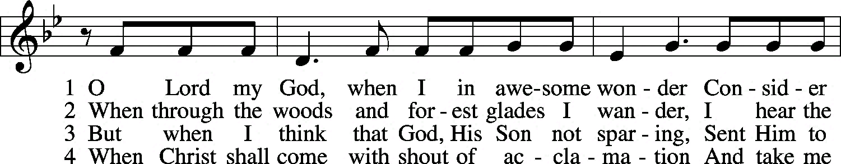
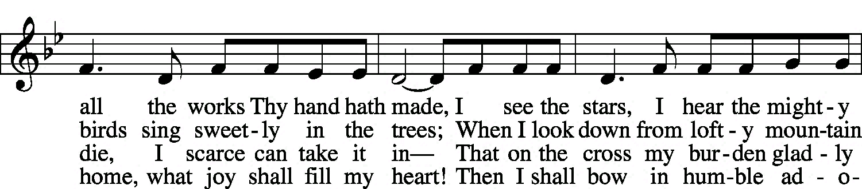
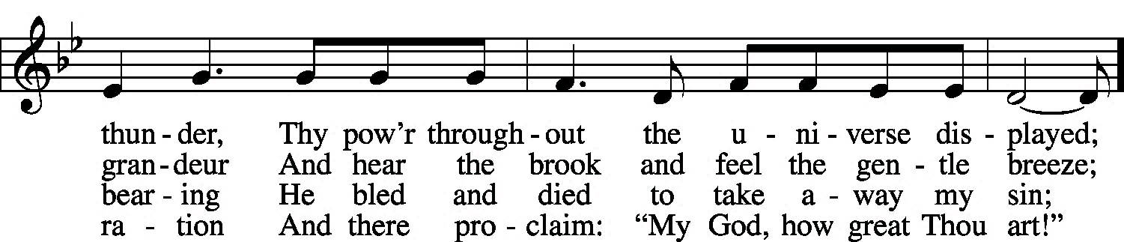
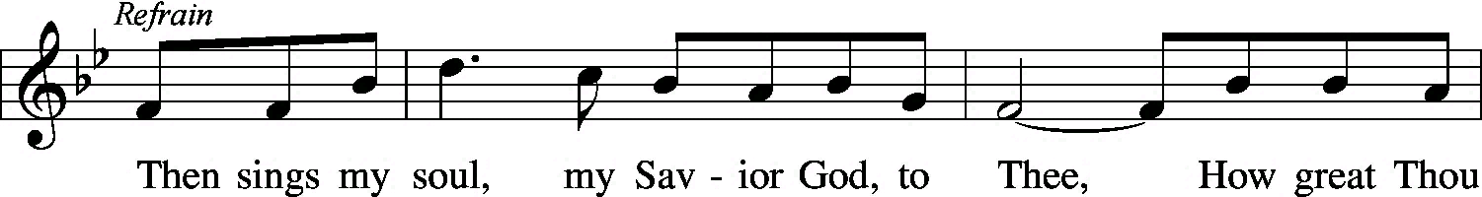
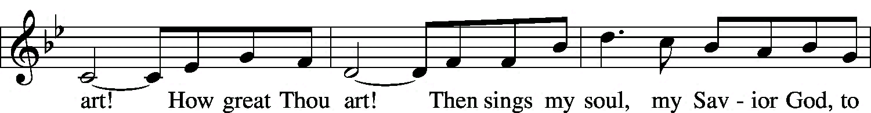
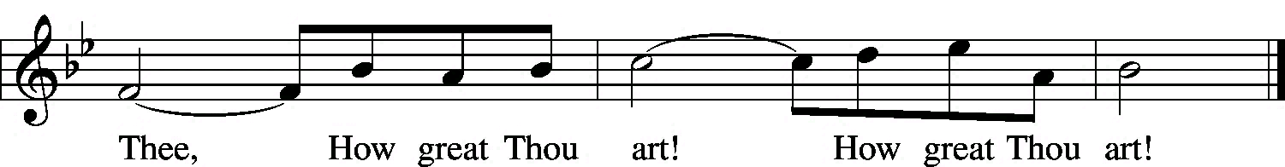
© 1953, renewed 1981 Manna Music. Used by permission: LSB Hymn License .NET, no. 100012217.

