The Didache
Lesson 4: The “Yes” of the Faith (Chapter 3)
By Pr Rich Futrell, Jan 22, 2012

For the “yes” of the faith, the Didache teaches us to see the good in the crosses we are given to bear. We are to see that even the distasteful aspects of our life have some godly purpose. Even when we cannot understand why, we are called to see such “crosses” through the eyes of faith.

The “Yes”

3:7 Instead, be humble, since the humble will inherit the earth.

Matthew 5:5: “Blessed are the humble, for they will inherit the earth.”

Philippians 2:5-8

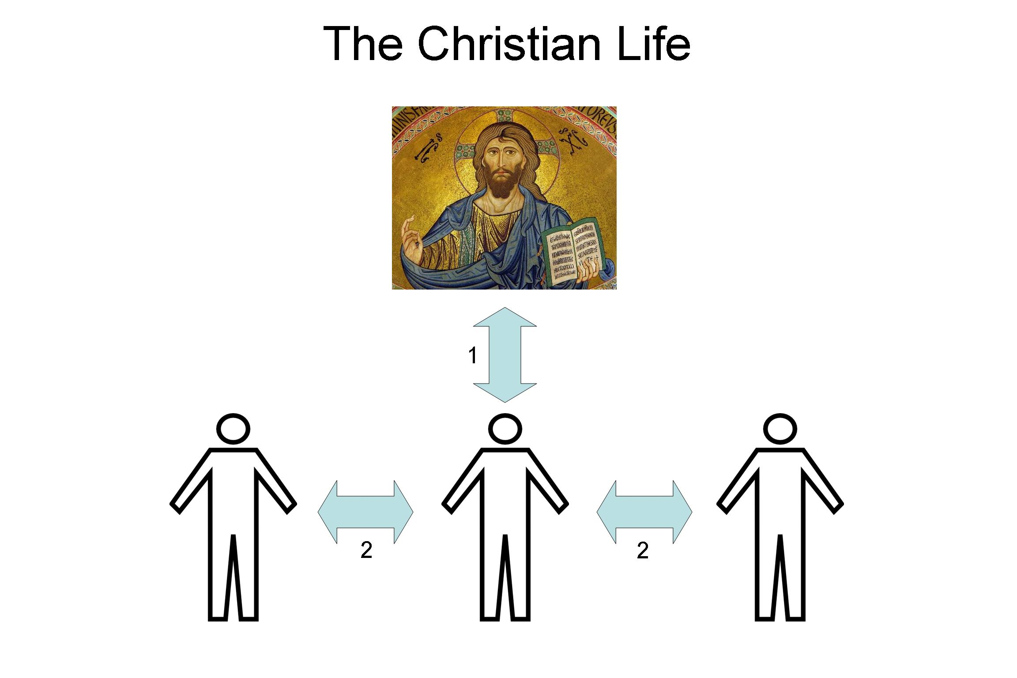
Have the mind of Christ Jesus. Although existing in the form of God, he did not consider equality with God as something to exploit. Instead, he emptied himself by taking the form of a slave, being made in human likeness. And when he had come in human form, he humbled himself by becoming obedient to death--even death on a cross!

For Christians, humility is not simply for humility’s sake. If that were so, then humility would be turned into a work to save us. Instead, being humble is having the mind of Christ. Being humbled is to being brought into Christ’s humility, so we may share in Christ’s glory in eternity.

Paul describes the result of this humility in Romans 6:3-5:

Don’t you know that all of us who were baptized into Christ Jesus were baptized into his death? Therefore, through baptism, we were buried with him into his death, so that, just as Christ was raised from the dead through the Father’s glory, we too may walk in newness of life. For if we have become joined to him in the likeness of his death, we will certainly also be joined to him in the likeness of his resurrection.

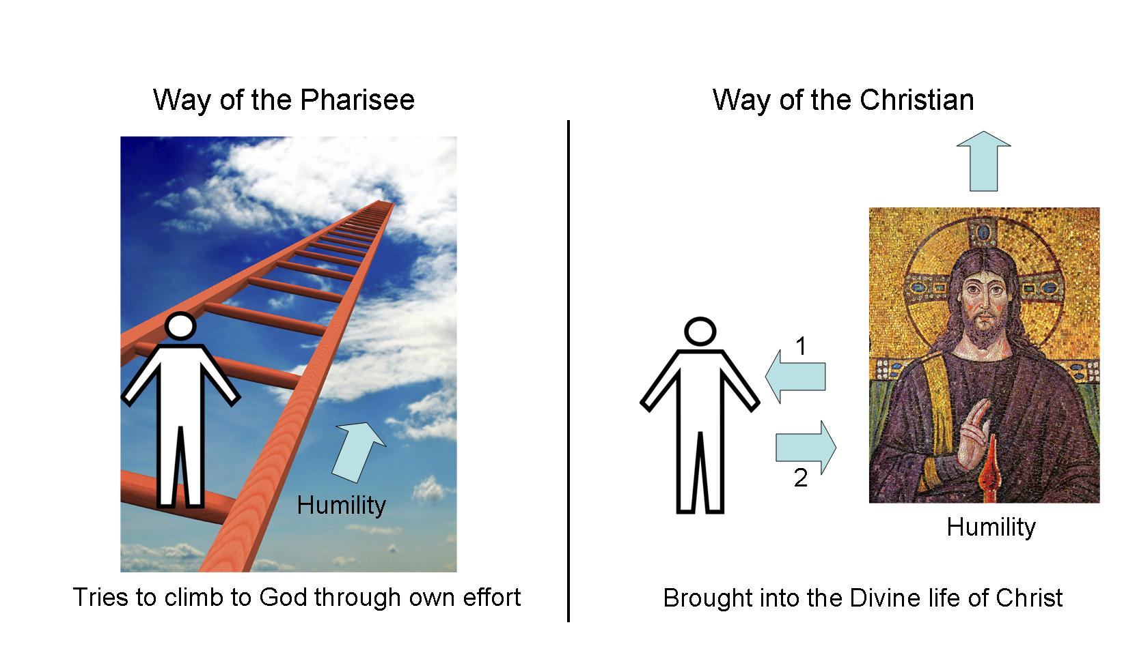

3:8 Be patient,
compassionate,
without guile,
gentle,
good,
and with trembling, treasure the Word you have received.

Isaiah 66:2: “So declares the LORD. ‘These are the ones I look on with favor: one who is humble and submissive in spirit, and who trembles at my Word.’”

This verse of the Didache is listing typical fruits of the Spirit (Galatians 5:22-23). Here, the 1st-Century instructor would use this verse to teach about the work of the Holy Spirit in one’s life. But, tying into the fruits of the Spirit, would be that which helps enable those fruits to mature into their fullness: “and with trembling, treasure the Word you have received.”

- Discuss.

3:9a Don’t exalt yourself
- and you will not open your heart to presumption.

1 Corinthians 4:6-7: “…that none of you may be inflated with pride in favor of one over another. For who regards you as superior? What do you have that you did not receive?”

- What’s the purpose of not exalting yourself, especially in eternal terms?

3:9b Don’t join your soul to the mighty,
- but to the righteous and lowly.

- With “earthly eyes,” what is the Didache saying?

- With the “eyes of faith,” what is the Didache saying?

- Tie in Jesus with “joining your soul … to the righteous and lowly.”

3:10 Accept whatever happens to you as a blessing, knowing that nothing happens apart from God.

Romans 8:28-29: “We know that all things work together for the good of those who love God, those who are called according to his purpose. For those he foreknew he also predestined to be conformed to the image of His Son, so that He [Jesus] would be the firstborn among many brothers.”

- What is God doing when He ensures that “all things work together for the good of those who love” Him?

- Why then can you “accept whatever happens to you as a blessing?”

