The Didache
Lesson 3: The Second Great Command (Chapter 2)
By Pr Rich Futrell, Jan 15, 2012

As we continue studying the Didache, we find that it does not directly use the Ten Commandments as a guide for Christian behavior (3rd use of the Law). Instead, the Didache continues with Jesus’ summation of the Law: love God and love neighbor.

If you were to compare the Didache’s “dos and don’ts,” you would find that it doesn't even mention some of the contents of the Ten Commandments. This, however, is not repudiation of the Ten Commandments, but a focused application of Jesus’ summation of the Law within Roman society. In the Didache, we learn of common practices within the Roman Empire that are incompatible with Christianity.

2:1 The second commandment of the teaching is this:

- 2:2 Do not kill.
- Do not commit adultery.
- Do not corrupt boys.
- Do not have illicit sex.
- Do not steal.
- Do not practice magic.
- Do not make potions.
- Do not kill a child through miscarriage or once it is born.
- Do not covet what belongs to your neighbor.

- The prescription against pedophilia says, “Do not corrupt boys?” What does this tell us about life in the first-century Roman Empire?

- When the Didache describes the prohibition against pedophilia as not “corrupting,” what more is at stake than simply the sex act?

- Discuss what is illicit sex (porneia in the Greek).

The prohibition against making potions was not of making medicine itself (or potions used in that sense). Instead, it focused on what was connected with them--pagan incantations that were to make them effective, which took away from God.

- Discuss modern medicine. Can it become an idol that takes away from God?

Sirach 38:1-2, 4 reads, “Honor the physician according to your need of him, for the Lord created him; for healing comes from the Most High … The Lord created medicines from the earth, and a sensible man will not despise them.”

- Reconcile the Didache’s prohibition against making potions with Sirach.

- What does the Didache’s “Do not kill a child through miscarriage or once it is born” cover?

The Five Sins of Speech

- 2:3 Do not swear falsely.
- Do not bear false witness.
- Do not speak evil of others.
- Do not bear grudges.
- 2:4 Do not be double-minded or double-tongued,
  - for a double-tongue is a snare of death.

- 2:5 Do not let your words be false or empty,
  - but fulfilled by action.

A Jewish philosopher from Alexandria, Philo (20 BC – 50 AD), said this about swearing oaths. If someone were to swear an oath invoking the name of God, he must not give “testimony concerning matters that are in doubt” (Decalogue 86). In our judicial system, this is the difference between not telling a lie and “telling the truth, the whole truth, and nothing but the truth.”

- Discuss this difference relating to the Didache’s “do not swear falsely” and “do not be double-minded.”

Excursus on the Connection between Believing and Doing

James 1:7-8 reads, “[A doubter] should not expect to receive anything from the Lord; he is a double-minded man, unstable in all his ways.”

Jesus said, “It’s not what goes into the mouth that defiles a person, but what comes out of his mouth, that is what defiles him” (Matthew 15:11).

Romans 10:10 reads, “With the heart one believes and is righteous and with the mouth one confesses and is saved.”

Paul’s “and” between the two main thoughts of Romans 10:10 is acting as a copula--joining two ideas into one. Paul isn’t listing two unrelated activities--believing and confessing--but one. As one believes, so he confesses. As one confesses, so he believes. When we separate believing and doing into two, completely different spheres, we import an alien way of thinking into the thought patterns of the New Testament.

An inseparable connection exists in the Greek words the New Testament uses to convey believing and doing, justifying and sanctifying. The word dikaios (a noun) means “equitable, innocent, and righteous.” Dikaioo (a verb) is more difficult to translate because it has various shades of meaning. They range from acquitting to being made righteous. In other words, that which justifies (acquits, declares righteous) also sanctifies (makes righteous).

What does this mean? God takes those who are stained with sin and guilty and makes them innocent and righteous. God forgives us of our sins and makes us into His righteous people. The New Testament conveys this truth using the same Greek root-word for both.

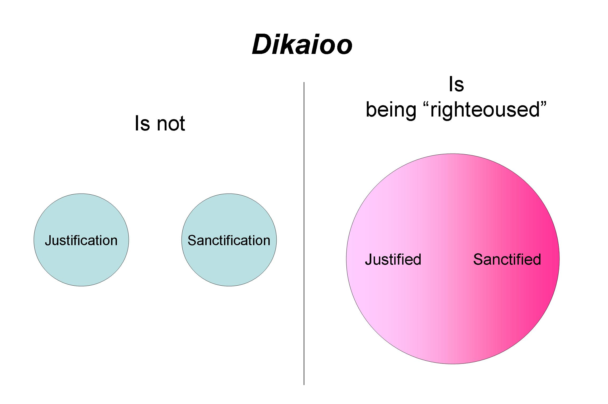

- Now understanding that believing and doing are “flip sides of the same coin,” tie in how being double-minded and double-tongued are snares of death.

- Relate the Didache’s “Do not let your words be false or empty, but fulfilled by action” with James’ “faith by itself, if it does not have works, is dead” (James 2:17).

The Five Sins of Attitude

- 2:6a Do not be covetous,
- or greedy,
- or hypocritical,
- or spiteful,
- or arrogant.

Jesus said, “No one can serve two masters. Either he will hate the one and love the other, or he will be devoted to the one and despise the other. You cannot serve God and wealth” (Matthew 6:24).

- If one is serving his greed and covetousness, whom then is he not serving?

- If the first two prohibitions speak against improper attachment to wealth (mammon), what do the last three deal with?

Conclusion of the Didache’s Chapter 2

- 2:6b Do not plot evil against your neighbor.
- 2:7 Do not hate anyone:
  - but some you will correct,
  - for others you will pray,
  - and some you will love more than your very own life.

Chapter two finishes by focusing on the positive aspects of what a Christian is to do! How does not hating anyone show itself lived out in real life? The Didache lists three actions. The implication is that one will need discernment to know whom he should correct, for whom he should pray, and for whom he should be willing to give his life!

1. Correcting others

Matthew 18:15: “If your brother sins against you, go and rebuke him in private. If he listens to you, you have gained your brother.”

- Whom should you correct?

- How is this an act of love?

- What does “gain a brother” mean?

2. Praying for Others

1 Timothy 2:1, 4: “I urge that petitions, prayers, intercessions, and thanksgivings be made for all people … [for God] wants all people to be saved and to come to a knowledge of the truth.”

- What then is the primary purpose of praying for others?

3. Loving another more than your own life

John 15:13: “Greater love has no one than this, that one lay down his life for his friends.”

Ephesians 5:25-26: “Husbands, love your wives, just as also Christ loved the Church and gave Himself for her to make her holy [hagiazo], having cleansed her by the washing of water with the word.

- Why did Christ lay down His life?

- When then is the purpose, if required, of laying down your life?

- What is the purpose for correcting, praying, and laying down your life?

- If the salvation and strengthening of another’s faith is the purpose for what we do in the Church, what actions do you see in our life that can also contribute to these ends?

Conclusion

An early Church pastor and co-worker with Paul, Barnabas, would later write about the seriousness of living out the faith. He said it wasn’t that doing such acts that by themselves save. Instead, this was the focus: “Brothers, give careful attention to our salvation, so the Evil One will not cause some error to slip in among you and, thereby, hurl us away from our Life” (Barnabas 2:8). This is exactly what the Apostle Paul wrote: “So, those who think they are standing firm, be careful not to fall” (1 Corinthians 10:12).

