The Didache: Worship Matters; Bishops and Deacons
Lesson 14: (Chapters 14-15)
By Pr Rich Futrell

Worship Matters

The Didache, chapter 13, brought out how to provide for prophets (pastors) who have settled in a particular place. Now, it covers when to worship and even touches on what worship looks like.

14:1 And on the Lord’s own day, gather yourselves together, break bread, and give thanks. However, first confess your sins, so your sacrifice may be pure.

Acts 20:7: “On the first day of the week, we [Luke and those with him] gathered together to break bread.”

1 Corinthians 16:2: “On the first day of the week, each one of you should set aside in keeping with your income, so that no collections [for the Jerusalem Christians] be made when I come.”

- What do these passages show about what already was the de-facto worship day for Christians?

- Discuss Jesus fulfilling the old Covenant and what this allowed in relation to worship.

Three parts are specifically mentioned about worship, one of which takes part before worship.

- What is “confess your sins?”

- What is “break bread”?

- What is “give thanks”?

- Why do you think the Didache here refers to the Lord’s Supper as “break bread” instead of “eucharistize,” Thanksgiving?

- Why is one to confess his sins?

Excursus: Why is the Lord’s Supper referred to as a “Sacrifice”

First, the Lord’s Supper is done in remembrance of the one-and-only sacrifice of Christ once offered on the cross for our sins. In the Lord’s Supper, we are simply receiving what Christ’s sacrifice gives us: forgiveness of sins, life, and salvation. To call the Lord’s Supper a “sacrifice” in that sense is fine, for it points back to Christ’s sacrifice and, because of that, what He give us in His Supper.

Second, in the early church, people brought the bread and wine used for the Lord’s Supper and as part of their offerings, their sacrifices. So, to call the Lord’s Supper as a “sacrifice” in that sense is also fine.

Third, the prayers that surround the Sacrament are sacrifices, that is, part of the response of faith, which is what prayer is. The prayers involved in the Lord’s Supper belong to our sacrifice of our praises and thanksgiving. Even the word “eucharist” (“thanksgiving”) as a name for the Lord’s Supper is a sacrificial term, which is not meant to detract from what Christ is giving to us in His meal. To call the Lord’s Supper a “sacrifice” in a eucharistic way, or the “Eucharist,” is also fine.

Yet, we Lutherans, do not usually use the term “sacrifice” for the Lord’s Supper. We choose not to because such a term can be confusing to those who only equate the term to what someone is doing for God. The main purpose of the Lord’s Supper is what Christ does for us. For that reason, we prefer to call the Lord’s Supper a “Sacrament.” Yet, if someone properly uses the word “sacrifice” for the Lord’s Supper, Lutherans have no problem with that.

-------------------

14:2 Let no one quarrelling with his brother come together with you until he has reconciled, so your sacrifice may not be defiled.

The Didache is simply bringing out the idea that if one sins against another in the congregation, he is not to receive the Lord’s Supper until he has repented and reconciled. Paul also teaches this truth in 1 Corinthians 11. There, Paul is addressing a situation where the richer members of the congregation were getting drunk before the Lords’ Supper and mocking the poorer members.

In 1 Corinthians 11:27, Paul says that if someone is unworthy to receive the Lord’s Supper (by such sinful, divisive behavior), he isn’t merely sinning against others in the congregation--he is even sinning against the Lord’s body and blood! In verse 28, Paul then tells someone to “judge” himself. Is he sinning against a brother or sister in Christ? If so, then repent and reconcile before communing. If not, then it’s all right to commune. In verse 29, Paul concludes his argument: One eats and drinks judgment to himself if he does not “judge the body,” that is, see if his reception of the Supper would be “defiled” as the Didache puts it.

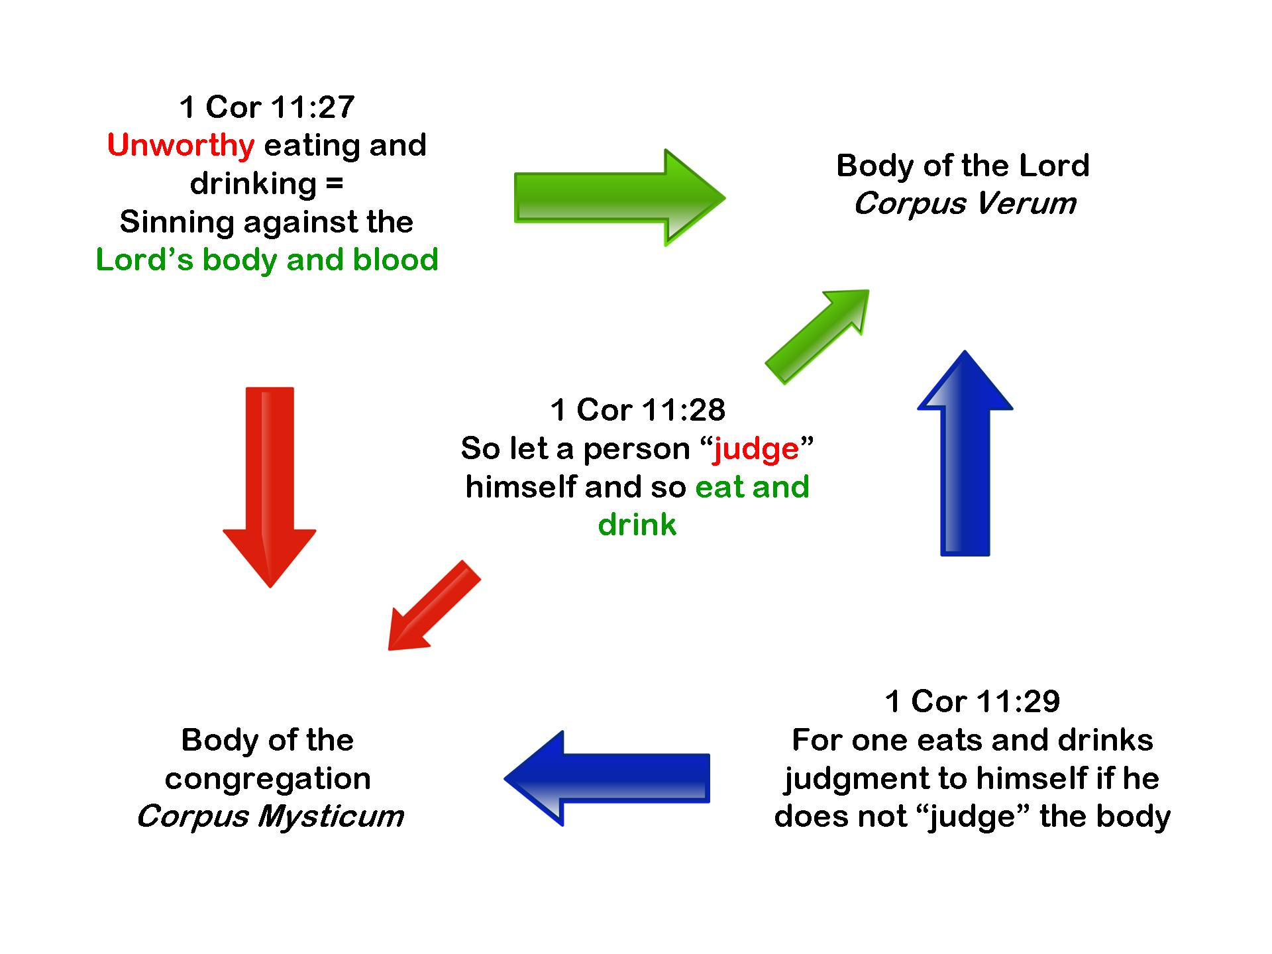

14.3 For this [sacrifice] is that which was spoken by our Lord: “‘In every place and every time, offer me a pure sacrifice. For I am a great king,’ says the Lord, ‘and my name will be wondrous among the Gentiles.’”

Malachi 1:11, 14:

“From the rising of the sun to its setting, and in every place, incense will be offered to my name, and a pure offering, for my name will be great among the Gentiles,” says the Lord almighty … “for I am a great king.”

The Didache loosely quotes Malachi 1:11, 14, and sees the prophetic promise there as being fulfilled in Christ. The Didache sees these verses as a prophecy pointing forward to the Lord’s Supper, and because of that, it should only be celebrated and received properly. If not, then it is an “impure sacrifice”; it is the equivalent of offering an impure sacrifice in the Old Covenant. That’s how seriously we are to take the proper reception of the Lord’s Supper!

Bishops and Deacons

At first glance, chapter 15 seems to be discussing a different class of clergy then it has mentioned earlier, for it uses the word “bishop.” However, this is not the case, for the Didache also uses the term “prophet-teacher” when referring to these bishops. So then, the Didache is not referring to a different class of clergy but shifting its emphasis.

What is this emphasis? It’s the proper celebration and reception of the Lord’s Supper. That’s why the term bishop (overseer) and deacon (assistant) are now used. One of their functions is to ensure that a congregation only celebrates the Lord’s Supper properly. This means that those who are to receive it are those who have repented and reconciled as needed (we call this “closed communion”). The Lord’s Table is not open to those who refuse to repent and reconcile.

- If properly celebrating the Lord’s Supper was such a “big deal” in the early Church that it is the main reason for selecting bishops and deacons, what does that say about the role of the Lord’s Supper in the early Church?

15:1 So then, choose for yourselves bishops [overseers], as well as deacons [assistants], who are worthy of the Lord:
- Men who are gentle,
- not lovers of money,
- truthful,
- and tested—
  - for, among you, they likewise carry out the service [literally, “liturgize the liturgy”] of the prophet-teachers.

- Discuss “choose for yourselves” and church polity when it comes to pastors.

- May a congregation choose whomever it wants to be its pastor?

15:2 That is why you are not to disrespect them, for they are your honored ones with the prophet-teachers.

Hebrews 13:17: “Obey your leaders and submit to them, for they are keeping watch over your souls, as those who must give an account. Let them do this with joy and not with groaning, for that would be of no benefit to you.”

- Discuss the pastor-congregation relationship.

15:3 Also, correct one another, not in anger, but in peace, just as you find it in the Gospel.

Here, “the Gospel” is probably referring the St. Matthew’s Gospel, the only Gospel probably circulating when the Didache was written. So we turn to St. Matthew’s Gospel to see what it says.

Matthew 18:15-18:

If your brother sins against you, go and correct him in private. If he listens to you, you have won your brother. But if he won’t listen, take one or two more with you, so “every word may be established by the mouth of two or three witnesses.” If he pays no attention to them, tell it to the congregation. But if he doesn’t even pay attention to the congregation, treat him as you would a pagan or a tax collector. I assure you: Whatever you bind on earth will have been bound in heaven, and whatever you release on earth will have been released in heaven.

- Discuss correction, repentance, and reconciliation.

- Discuss the congregational use of the “keys.”

15:4 And do your prayer, alms, and all your actions as you have it in the Gospel of the Lord.

Matthew 6:2: “When you give to the needy …”

Matthew 6:5: “When you pray …”

Matthew 6:16: “When you fast …:

- What are the purposes of these spiritual disciplines?

- Why do you think the Didache immediately mentions these spiritual disciplines after it deals with resolving conflict in the congregation?

