The Didache: Apostles and Prophets, Pt. 1
Lesson 11: (Chapter 11:1-6)
By Pr Rich Futrell, April 1, 2012

After going over the epicenter of the New Covenant, the Lord’s Supper, the Didache, tackles a most-practical issue in its day. It deals with those who would visit, claiming to be an apostle, prophet, or pastor (remember this was still early enough when the Apostles were still alive).

Knowing the Truth from a Lie

11:1 So, if someone should come to you and teach all that was earlier taught, receive him.
11:2 But if the teacher has turned away, teaching another doctrine, destroying this teaching, do not listen to him. However, if his teaching brings one into the Lord’s righteousness and knowledge, receive him as the Lord!

2 Thessalonians 2:15:”So then, brothers, stand firm and hold to the traditions you were taught, whether by our [the Apostle Paul and Pastors Silvanus (Silas) and Timothy] spoken word or by our letter.”

1 Corinthians 11:2: “I praise you because you remember me in everything and hold to the traditions just as I [the Apostle Paul] delivered them to you”

- What does the Didache refer to when it says “teach all that was earlier taught” and “this teaching”? (Clue: What is the full title of the Didache?)

- May we pick and choose among the various teachings of apostolic doctrine? (Clue: the word “all” in Didache 11:1)

- Apply this truth in a day of over 20,000 denominations (and even “non-denominational churches”). How can we make sense of this mess?

Matthew 7:15: “Watch out for false prophets. They come to you dressed like sheep, but inwardly they are vicious wolves.”

Hebrews 13:17: “Obey your leaders and submit to them, for they are keeping watch over your souls, as those who will give an account. Do this, so their work will be a joy, not a burden, for that would be of no benefit to you.”

Romans 16:17-18: “I urge you, brothers, watch out for those who cause divisions and pitfalls contrary to the doctrine you have learned. Keep away from them. For such people are not serving our Lord Christ, but their own appetites. By smooth talk and flattering words they deceive the hearts of the unsuspecting.”

- What is Paul referring to when he mentions “the doctrine you have learned”?

- So, if a “teacher has turned away, teaching another doctrine,” how are you to treat him?

- True doctrine “brings one into the Lord’s righteousness and knowledge.” What does this mean?

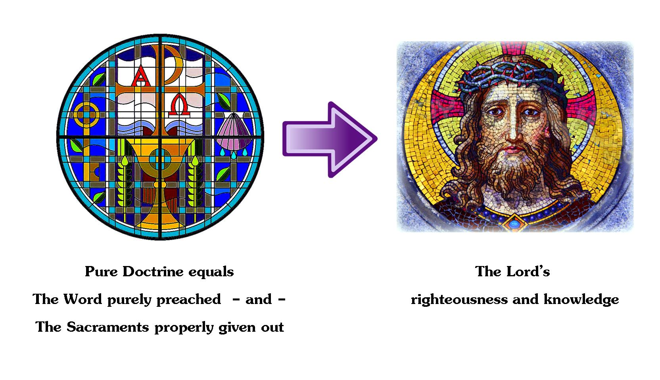

- How are you to treat such a teacher who purely preaches the Word and properly give out the Sacraments? Why?

Apostles

11:3 Concerning the apostles and prophets, based on the dogma of the Gospel, treat them this way:

- 11:4 Receive every apostle who comes to you as you would the Lord.
  - Normally, he will stay only a day.
  - If needed, he may stay the next day.
  - 11.5 But if he stays three days, he is a false prophet.
- 11:6 When he leaves,
  - let the apostle receive nothing but [enough] bread until his next night’s lodging.
  - If he should ask for money, he is a false prophet.

Excursus on the Difference between the Apostles and Prophets

The Didache mentions both Apostles and prophets. Today, most recognize the role of the Apostles in Christ’s Church, but the idea of prophets in a New Testament context eludes us. We often wrongly view prophets as only an Old Testament event.

Ephesians 2:19-20: “So then, you are no longer foreigners and strangers. Instead, you are fellow citizens with the saints, and members of God’s household, which is built on the foundation of the apostles and prophets, with Christ Jesus himself as the cornerstone.”

Ephesians 4:11-13:
And He [Jesus] Himself gave—
on the one hand,
- apostles;
on the other,
- the prophets,
- the evangelists,
- and pastor-teachers—[why?]
- for equipping the saints,
- to do the work of ministering,
- to the building up of the body of Christ,
[to what end?]
  - until we all may come into the fullness of the oneness of the faith,
  - and the knowledge of the Son of God,
  - into complete manhood, into the full measure of Christ’s maturity...

Because of how these verses have been punctuated since the Revised Standard Version, Ephesians 4:11-13 is one of the most-confused passages of the New Testament. It is usually translated in a way that confuses the grammar of the original Greek.

In these verses, the Greek text has only one verb--it’s in verse 11: “gave.” In these verses, Jesus is the focus and the doer of the verb “give,” not the Apostles, pastors, or saints. Paul lists what Christ gives to His Church into two broad categories:

- the Apostles and
- their successors: prophets, evangelists, and pastor-teachers.

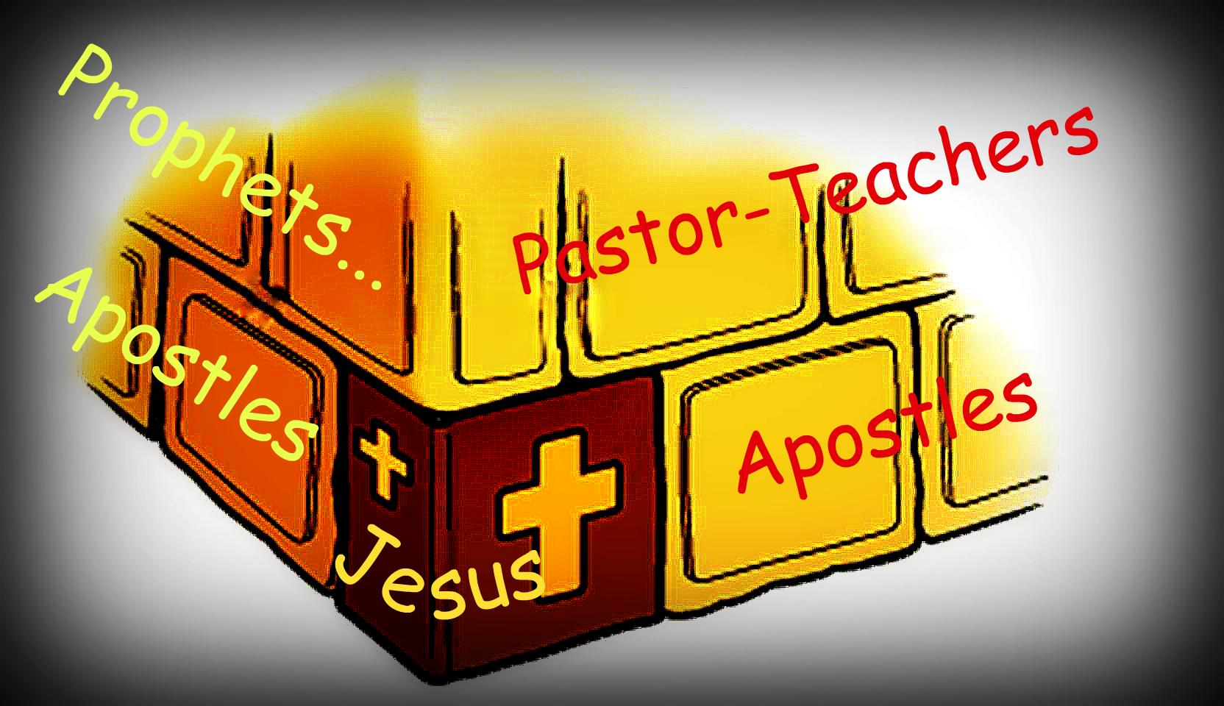
When Paul mentions “the Apostles and prophets,” he is distinguishing them in some way, as does the Didache. In the New Testament Church, Christ is the beginning; He is the “Cornerstone.” Christ then gave to His Church “Apostles,” the Church’s foundation, from whom came His apostolic doctrine. Following the Apostles are the New Testament “prophets, evangelists, and pastor-teachers,” who also are part of the foundation, built on the first foundation of the Apostles. In today’s language, we call this second group “pastors.”

How then do we know that pastors are the successors in the Church to preach and teach apostolic doctrine? The authorship of some of the New Testament’s epistles confirms this.

- 1 Corinthians: The Apostle Paul and Pastor Sosthenes
- 2 Corinthians: The Apostle Paul and Pastor Timothy
- Philippians: The Apostle Paul and Pastor Timothy
- Colossians: The Apostle Paul and Pastor Timothy
- 1-2 Thessalonians: The Apostle Paul and Pastors Silvanus [Silas] and Timothy
- James: Not an apostle, but a pastor
- Jude: Not an apostle, but a pastor

This part about the prophets will fit together in next week’s lesson.

James 2:26: “For just as the body without the spirit is dead, so also faith apart from works is dead.”

- Why does the Didache link what an apostle does with his doctrine?

- What does that say about the link between faith and works, between doctrine and practice?

- What does the two-day limit and not asking for money reveal about agreed-to practices in the early New Testament Church?

- Are there any implications for us in deciding to have agreed-to practices in the Church?

Next week: How to deal with prophets (aka pastors).

