The Didache: The Spiritual Disciplines for Those in the Covenant
Lesson 12: (Chapter 8)
By Pr Rich Futrell, Mar 18, 2012

After the Didache goes over what brings someone into the New Covenant of Christ, it immediately moves into the spiritual disciplines for someone who is in the covenant: Prayer and fasting.

The spiritual disciplines that Jesus’ disciples are to bring into their lives help keep the sinful nature from taking over and causing them to walk in the way that leads to death. The spiritual disciplines that Chapter 8 of the Didache focuses on are prayer on fasting. The Christian discipline of almsgiving was earlier mentioned (Didache 1:6). Thus, the triad of Christian disciplines from Matthew 6 is completed.

Fasting

8:1 Don’t let your fasting coincide with those of the hypocrites.
- They fast on the 2nd [Monday] and 5th [Thursday] days of the week.
- So, you should fast on the 4th day [Wednesday] and the preparation [Friday] day of the week.

This verse shows the ancient date of the Didache. It’s an early Christian document, yet it still follows the Jewish ordering for the days of the week! This shows a Church still comprised mostly of ethnic Jews.
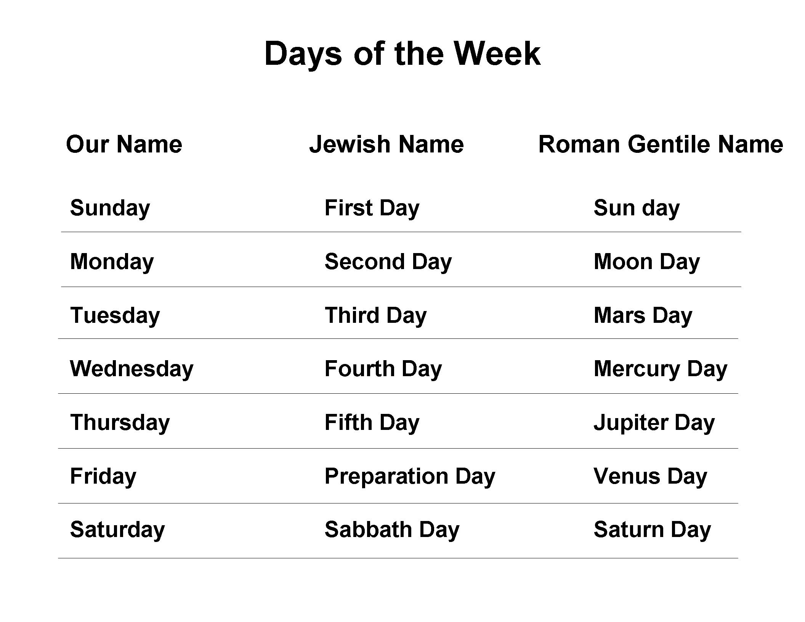
- Based on context, who are the “hypocrites”? Why did the Didache instruct its Gentile converts to fast on Wednesday and Friday?

- For us, does the rationale for fasting on Wednesday and Friday still make sense?

- What about fasting in some way during the penitential seasons of Advent and Lent?

Matthew 6:16-18: Jesus said, “And when you fast, do not look sad-faced like the hypocrites…. when you fast, anoint your head and wash your face. Then, it won’t be obvious to others that you are fasting.”

-------------

Excursus on Fasting

The Didache simply assumes that Christians will fast (“Don’t let your fasting …”). So does Jesus (“When you fast …”)! To understand this, we need to realize that fasting was simply part of the spiritual discipline of God’s people--Old and New Covenant!

The Bible, including the Old Testament Apocrypha, has about 100 references to fasting. The Old Testament shows much variety in fasting. Individuals would fast as well as a nation. People fast to obey the command of God or a leader. Some fasting is spontaneous, and some is planned. Some start fasting because of a vow they have made. Fasts last from a few hours to 80 days (obviously this was not a total fast, but limited)! We find the prophets of the Old Testament do not ignore fasting--they simply take it for granted.

The New Testament does not say as much about fasting. The first person we meet who is fasting is Anna, the prophetess. “She never left the temple, but worshiped night and day, fasting and praying” (Luke 2:37). The Gospels record Jesus’ 40-day fast in the wilderness, which is the only fast of Jesus that the Gospels describe for us.

So then, what is fasting? It is simply denying yourself the pleasure of food for a time to devote yourself better to prayer, to learn to discipline the body and its wants, and to focus more on one’s spiritual life.

The most ancient Christian fast days are Wednesdays and Fridays, which the Didache lists as days for fasting. Polycarp (died 156 AD), a disciple of the Apostle John, urged: “. . . let us give up the vanity of the crowd and false teachings and return to the Word handed on to us from the beginning . . . being sober in prayer and persevering in fasting.” The Shepherd of Hermas suggested a “fast” of bread and water and to give the money normally spent on food to the poor (what a gracious idea!). The writer of 2 Clement (100-140 AD) wrote: “Fasting is better than prayer, almsgiving than both” (A loose quotation of Tobit 12:8).

When we learn to fast according to the Gospel, it should change how we view it! Fasting then simply recognizes that our Lord encourages fasting. That’s why a Christian should want to fast if he does. Jesus encourages fasting simply as a way of life for His disciples (Matthew 6:16), as He does for prayer.

A Christian fasts because he wants--in Christ--to deny the demonic powers control of his fleshly passions, depriving Satan to use loss of control in fleshly wants as an entry point into his life. This is a form of Christian discipline the Christian Church has recognized since the beginning.

Although fasting will cause one to be hungry since he won’t be eating as much food, it can be more than that. And it is the more-than-that part that should encourage us to consider fasting. Through fasting, one can hope to discover--in a more real way--that his dependency on food and feeling hunger is not the whole truth about who he is as a baptized child of God. In other words, a person is not defined by his wants and wishes. Physical hunger can also be a spiritual state in this way--it can be turned into a disciplined way to hunger more for God!

However, a Christian should not fast, merely seeking his own advantage at the expense of others (1 Corinthians 10:24). He should not fast to keep himself from serving others. And when he does fast, he should do quietly, in modest freedom.

Read “How You Might Fast” on page 189 in The Lutheran Study Bible.

------------------

8:2 But do not pray as the hypocrites, just as the Lord commanded in His Gospel. Pray in this way:

Our Father in heaven,
hallowed be your name.
Your kingdom come,
your will be done, on earth as it is in heaven.
Give us this day our daily bread,
and forgive us our debt,
as we also have forgiven our debtors.
And lead us not into temptation,
but deliver us from evil.
For Yours is the power and the glory forever.

8:3 Pray this three times a day.

The text of the Lord’s Prayer in the Didache is almost identical to the Lord’s Prayer in Matthew (“debt” is singular in the Didache). By referring to what Jesus said in the Gospel of Matthew as “just as the Lord commanded in His Gospel,” this shows the mid-50s as a reasonable date for the Didache.

Luke prefaces the Lord’s Prayer in His Gospel with these words: “When you pray, say …” (Luke 11:2). The Didache says to “pray this [the Lord’s Prayer] three times a day.”

- What does this say about the concern that praying the Lord’s Prayer every day or during every Divine Service can make it “empty repetition”?

- If something becomes “empty repetition,” is the problem with what is being prayed or the person praying?

