The Didache: Staying Faithful as a Gentile Convert
Lesson 10: (Chapter 6)
By Pr Rich Futrell, Mar 4, 2012

After describing the way of death, the Didache tells those being instructed not to be led astray, which leads one into the way of death..

6.1 Take care that no one leads you astray from the Way of the teaching [didache], since he is teaching you apart from God.

Jeremiah 23:32: “‘Indeed, I am against those who prophesy false dreams,’ declares the LORD. ‘They proclaim to them and lead my people astray by their lies and their recklessness. I did not send them or commission them, nor do they benefit these people in the slightest,’ declares the LORD.”

John 14:6: “[Jesus said,] ‘I am the way, the truth, and the life. No one comes to the Father except through me.’”

John 5:39: “[Jesus speaking to the other Jews:] ‘You examine the Scriptures because you think that in them you have eternal life; it is they that testify of me.’”

- What does “the way,” referring to Jesus, and “the way,” referring to the teaching, [didache] show how inseparable the two are?

- Can someone willfully choose to reject one part of the way without rejecting the other part of the Way?

Matthew 7:15: “[Jesus, said to the crowds listening to Him:] ‘Watch out for false prophets, who come to you in sheep’s clothing but inwardly are vicious wolves.’’’

Luke 10:16: “[Jesus, speaking to those whom He had sent to preach His Word:] ‘The one who hears you hears me, and the one who rejects you rejects me, and the one who rejects me rejects the One who sent me.’”

Romans 16:17-18: “Now I implore you, brothers, watch out for those who cause divisions and pitfalls contrary to the doctrine you have learned. Keep away from them. For such people do not serve our Lord Christ, but their own appetites. By smooth talk and flattering words, they deceive the hearts of the unsuspecting.”

- If someone is teaching you “apart from God,” what does that mean?

- How are you to treat him?

- However, is someone is teaching you “from God,” what does that mean?

- How are you to treat him?

The Interconnectedness between Jesus and His Truth

Today, we often want to separate the teacher from what is being taught. We separate what the pastor teaches as simply one valid opinion among many others. However--if the pastor is teaching what is from God--then the hearer is to receive what the pastor teaches as if from God Himself. If the pastor is faithful, God does not allow you to separate the pastor’s word from God’s Word.

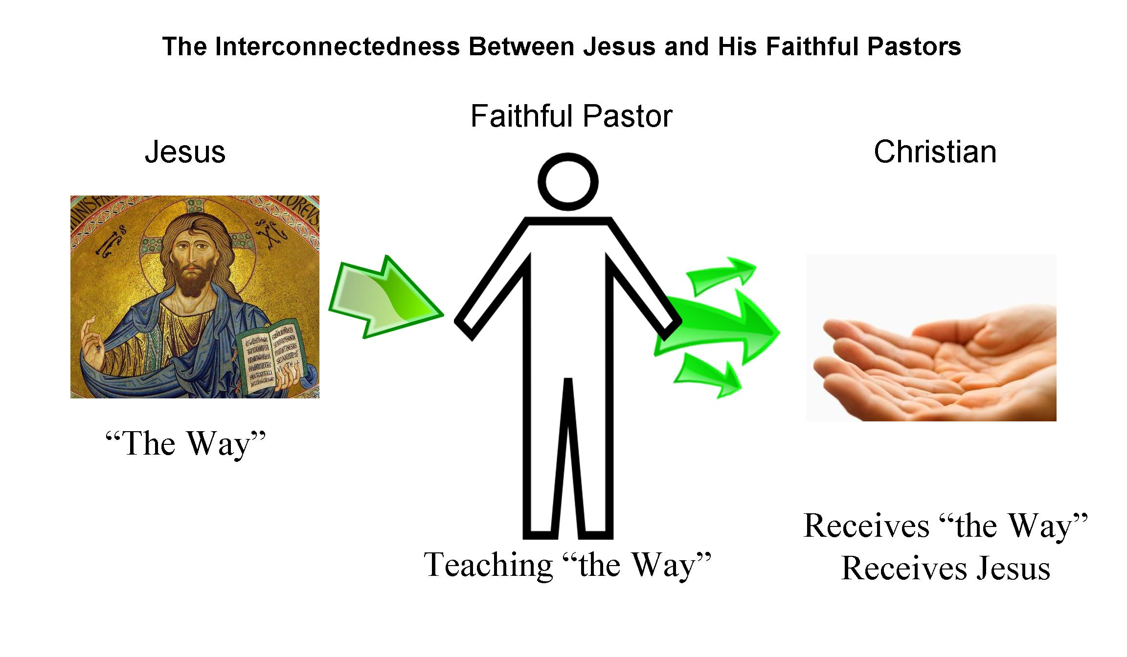

Gentile Converts in a predominately ethnically Jewish Church

6:2-3 If you can bear the whole yoke of the Lord, you will be complete; but if you cannot, do what you can. Concerning food, bear what you can, but especially be on guard against food sacrificed to idols, for it involves the worship of dead gods.

Here, the Didache is dealing with Gentiles learning to live with Jewish Christians, many of whom still chose to follow the Old Testament, Mosaic regulations.

Read Galatians 5:1-6

- What is the point of the Didache not demanding that converting Gentiles must follow the mosaic laws, such a circumcision and dietary regulations?

Read Acts 15:1-2, 22-29

- What is the “middle way” that the first Apostolic council chose to guide how Gentile Christians should live with Jewish Christians?

Read Romans 14:13-23

- Tie Didache 6:2-3 into our current-day context.

-----------------

Excursus: Can Someone Fall from the Faith?

Matthew 24:9-10: [Jesus speaking about the last times,] “Then you will be handed over to be persecuted and put to death, and you will be hated by all nations because of me. Then many will turn away from the faith and will betray and hate one other.

John 16:1: [Jesus speaking to His disciples,] “I have told you these things to keep you from falling away.”

1 Corinthians 10:12: So whoever thinks he is standing needs to watch out or else he may fall.

1 Timothy 4:1: The Spirit clearly says that in later times some will depart from the faith by devoting themselves to deceitful spirits and teachings of demons.

Discuss scenario: A Christian friend of yours understands and believes that God saves through baptism. He also believes that he receives Jesus’ body and blood in the Lord’s Supper. But those parts of His faith-life are incidental to him. He also finds the doctrinal hymns within Lutheranism to be boring. He would, instead, prefer to sing upbeat songs that focus on his emotions. So, he has chosen to go to the Baptist church because he likes how he feels when he leaves the service.

- Is he deliberately rejecting Jesus’ teachings?

- If so, what are the implications of him knowingly choosing a way that differs from the way of Jesus?

-----------------

